FRONTEND DEVELOPMENT

## TITLE OF THE PROJECT:

**E-Commerce: Shoe Store**

FACULTY MENTOR:

**Dr. SK Meera Sharief, M.Tech ,(Ph.D.)**

TEAM ID:

LTVIP2023TMID05807

TEAM LEADER:

R.HEMA SURYA LAKSHMI - 20T91A0574

## TEAM MEMBERS:

S.DHARANIKUMARGOWD - 20T91A0576

S.SUMANTH- 20T91A0578

B.RAJARAJESWARI - 21T95A0503

K.HAREESH- 21T95A0515

## Abstract

The e-commerce industry has witnessed remarkable growth in recent years, and the demand for online shopping experiences continues to rise. This project aims to design and develop an engaging and user-friendly e-commerce shoe store website using a combination of HTML, CSS, and JavaScript.

The primary objective of this project is to create a visually appealing and interactive platform that allows users to browse, search, and purchase a wide range of shoe products. The website will incorporate responsive design principles, ensuring compatibility with various devices and screen sizes. HTML will be used to structure the content and layout of the website, while CSS will be employed to style and enhance the visual elements, ensuring a consistent and attractive user interface.

The project will also involve the implementation of JavaScript functionalities to enhance user interactivity. Dynamic features such as product filtering, sorting, and a shopping cart system will be developed using JavaScript. Additionally, user experience will be enriched with animations, smooth transitions, and real-time updates.

To achieve these goals, the project will follow a systematic development process, including requirements analysis, design, implementation, and testing. The website's functionality and performance will be rigorously tested to ensure a seamless and efficient shopping experience for users.

In conclusion, this project aims to showcase the potential of combining HTML, CSS, and JavaScript to create a feature-rich and visually captivating e-commerce shoe store website. The resulting website will serve as a valuable example of modern web development practices and contribute to the growing body of knowledge in the field of e-commerce and user-centered web design.

# E-Commerce: shoe store

### Project Overview:

For this project, I implement an E-commerce website that sales shoes online using html and css and java script.

The requirements I fulfilled in this project are as follows:

* Database with 10 or more products with name, description, and cost
* Web page that allows a user to select multiple products to purchase and the quantity of each product
* Enter shipping address
* Calculate tax based on the state being shipped
* Calculate total cost
* **Empty the shopping cart** (there is a minor problem with this function: you need to press the empty button twice to delete all items in the cart)
* **UI design using CSS** (I used some CSS templates on the internet)

### Overview of the Architecture:

Software Architecture I Chose

I use **two-tier Client/Server architecture** to implement the project.

#### Scenario View

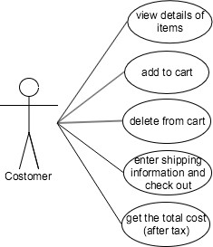

**Logic View:**

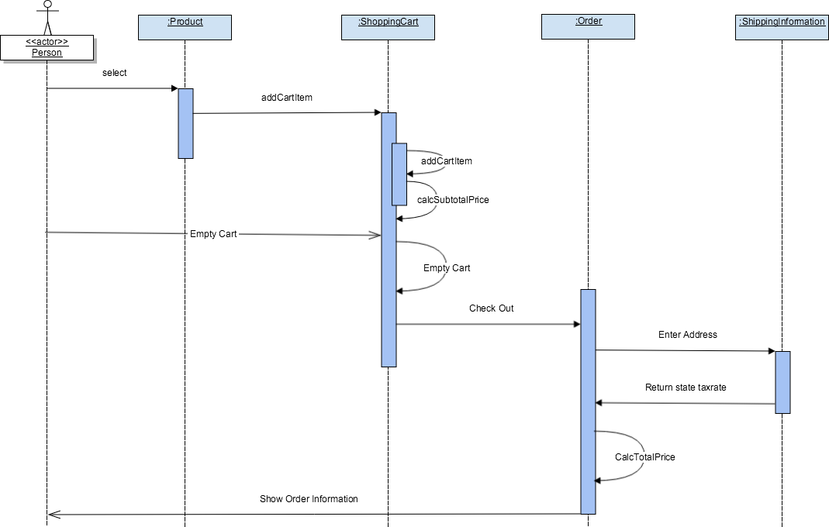

**Deployment View:**

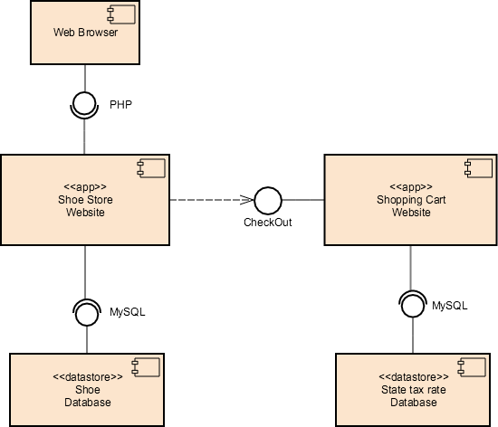

**Architecture Selection:**

**Analysis:**

The first requirement of this project is to provide a database that saves information of all products, we can store all databases involved in this website to the server, and we can consider the user of the website as the client. After analyzing all the requirements, it is pretty simple to come up with the idea to implement the project using client/server architecture. And because our website won’t involve a lot of databases and interactions, I choose to use two tiers, that is the client communicates directly to the server without any third layer between them. The following are some elements in this architecture.

**Components**: database storing information of each shoe; database storing state tax rates; PHP files that show the content of websites.

**Connectors**: the components in this system are interacted by client clicking events. Whenever the client clicks a link, according to the specific link, a function of PHP file would be invoked and bring the required data in database to the front end.

#### Trade Study

The purpose of the trade study is to compare and analysis different software architecture and choose the best one to implement the project. Before making the final decision, I’ve chosen several often used software architecture to compare and analysis: Client/Server architecture, Object-Oriented architecture, Service-Oriented architecture, Component-Based architecture.

**Object-Oriented Architecture**: There are two objects we can extract from the requirements of

the project: customer and the products. Because we don’t need to implement the login system for the customers, so object customer only has methods and no properties. And instead of using class, we can easily use database to store all the information of the products, which is easier to

for implementation and maintenance. So I don’t think object-oriented architecture is a suitable for the project.

**Service-Oriented Architecture**: The goal of SOA is to achieve “loose coupling” among interacting and contracted services via communication protocols. It is usually meant for large- scale system. In our system, the only interaction is between the customer and the website invoked by clicking links. So the coupling of components is already loose. Therefore, SOA is a bit too complicated for our system.

**Component-Based Architecture**: I think component-based architecture has a lot of similarity to object-oriented architecture: They both decompose the system into components(classes) and are both good for reusability in the future. But component-based architecture can allow multiple levels of encapsulation and multiple interfaces between components, which makes it more flexible and useful. Actually component-based architecture is a good way to implement the E- commerce website, because the components in the system can be easily extracted and reused in the future version of the E-commerce website. But as I mentioned before, for this project, S/C architecture is the optimal option.

### System Implementation:

As we did this project based on HTML ,CSS, JAVASCRIPT programming languages.

The below images shows the code about these three languages as reference code or image.

HTML code for website:

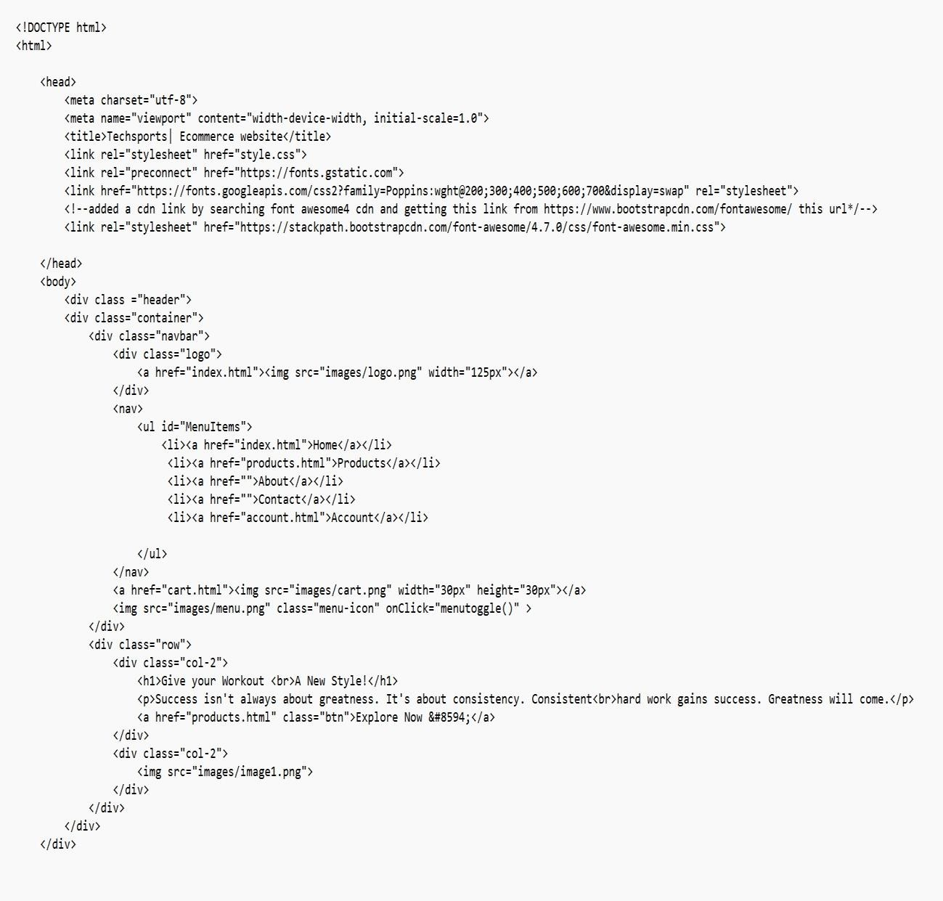

HTML code for product:

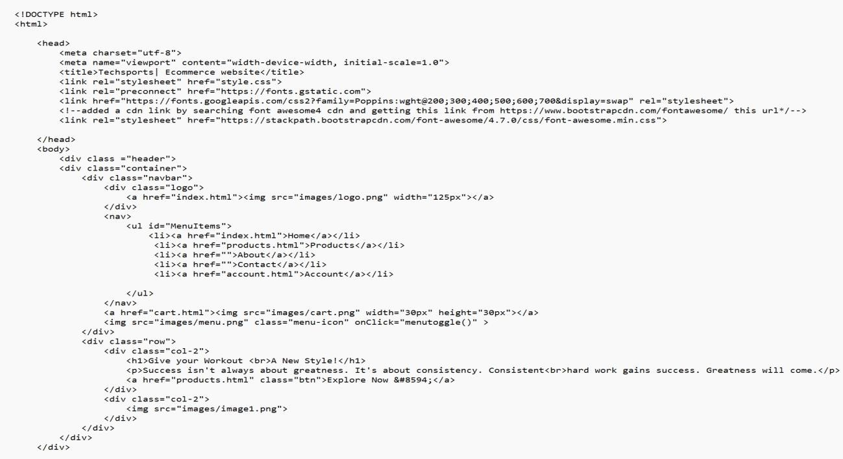

HTML code for cart:

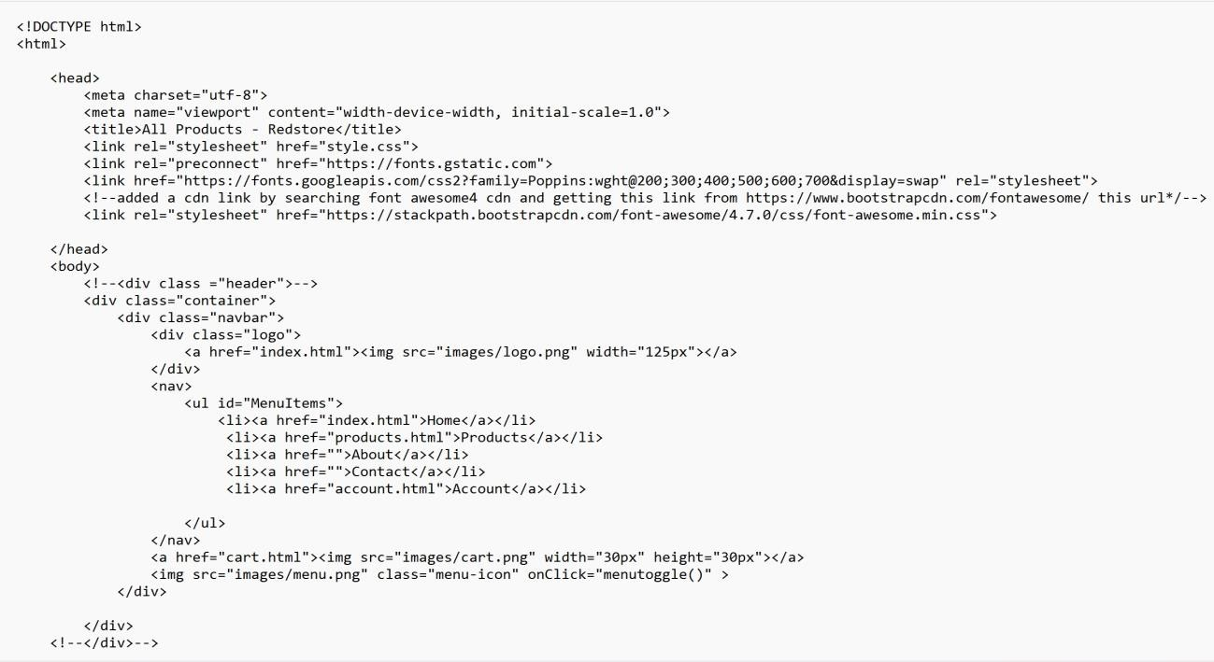

CSS code for product**:**

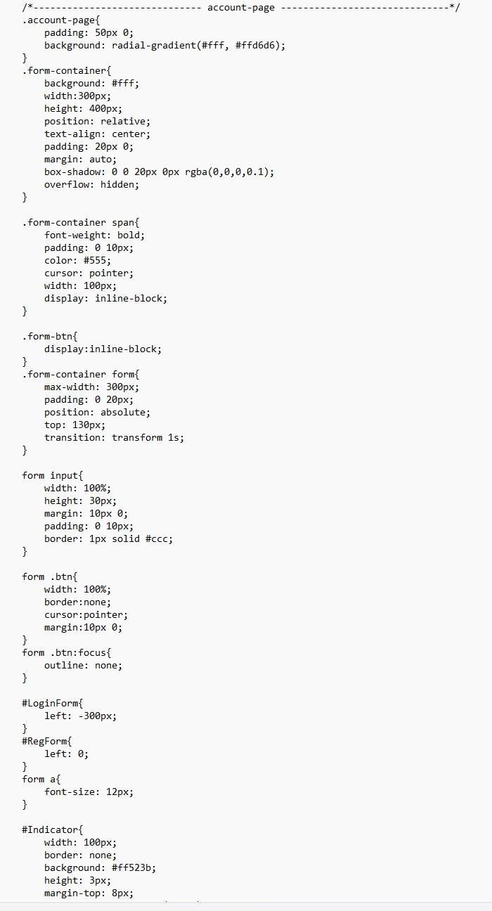

CSS code for account page:



### Screenshots of the Website:

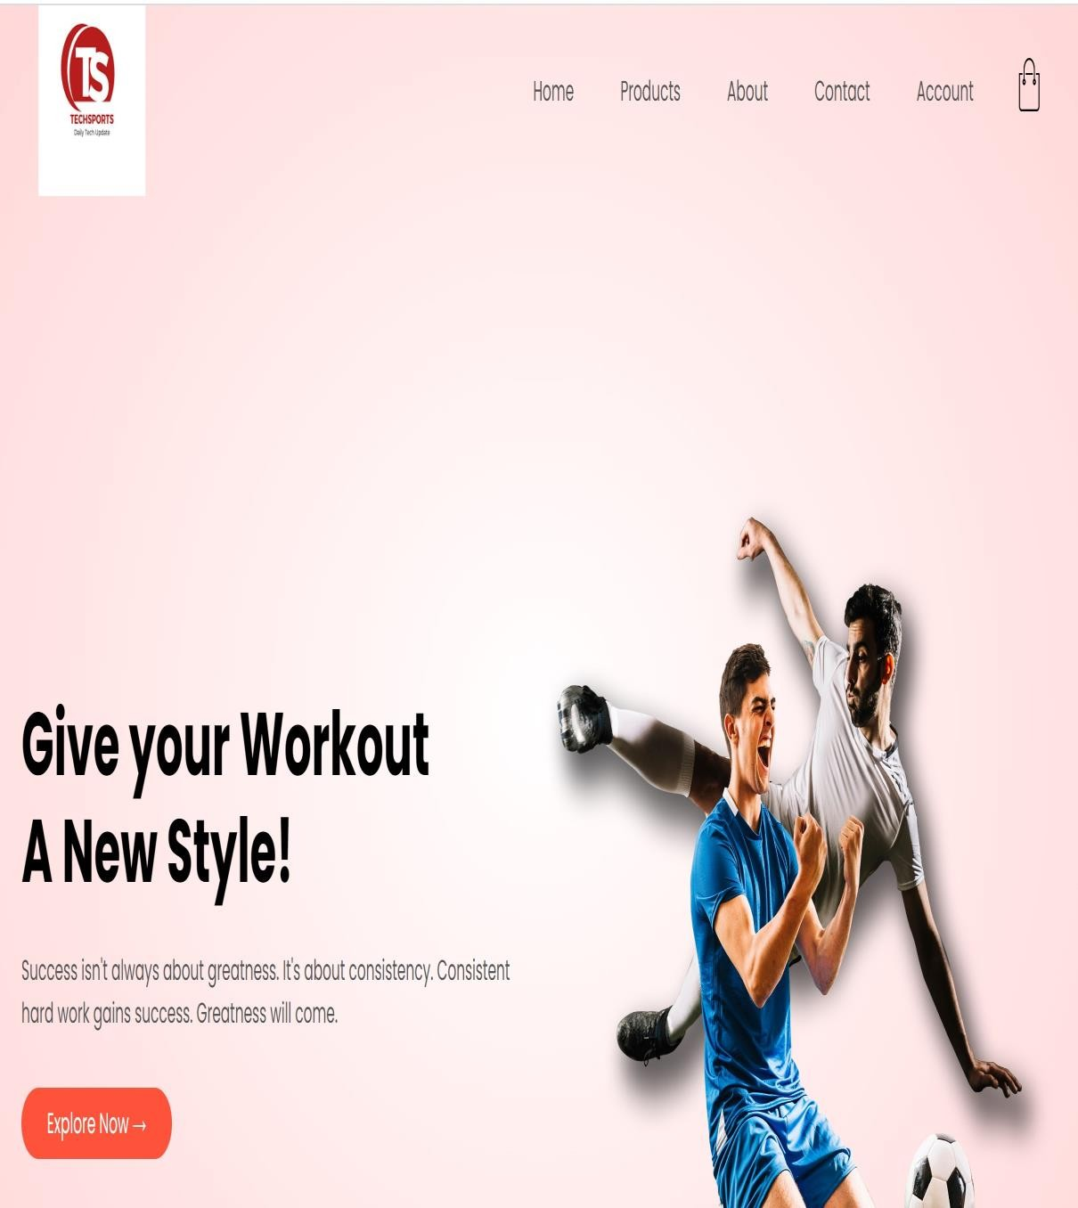

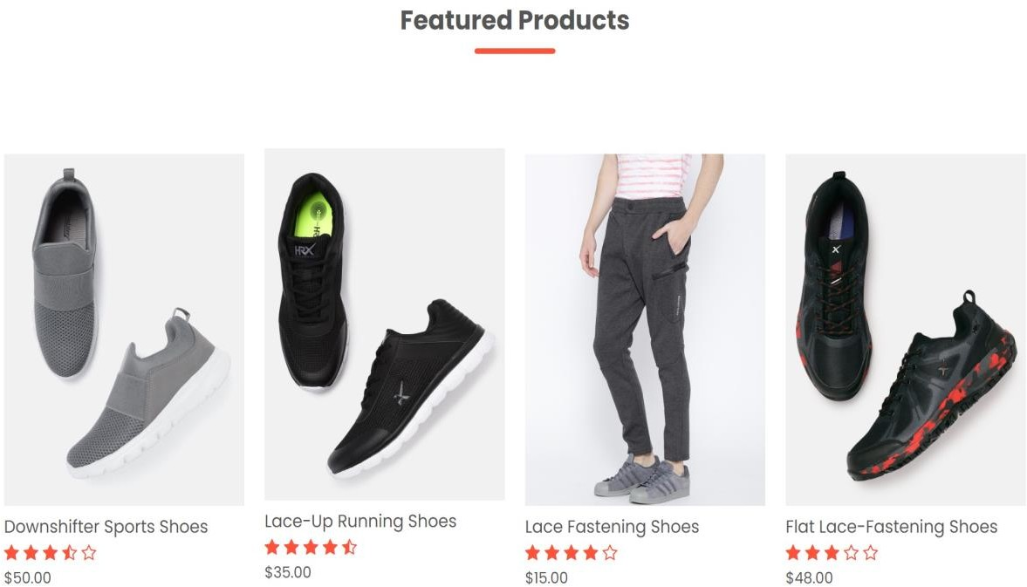



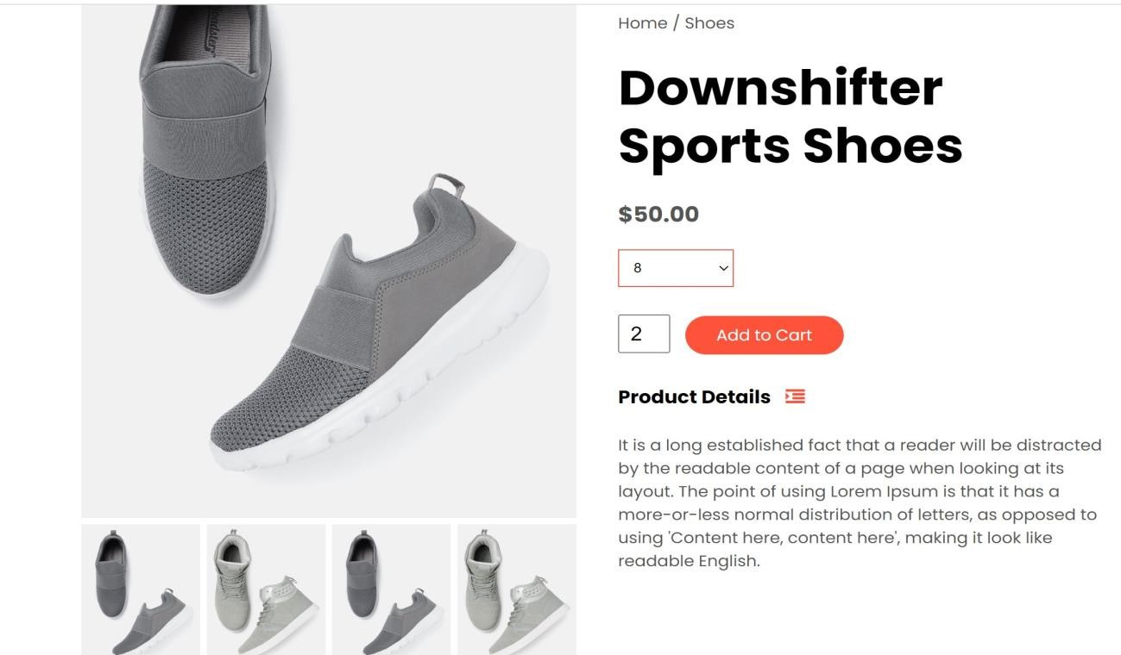

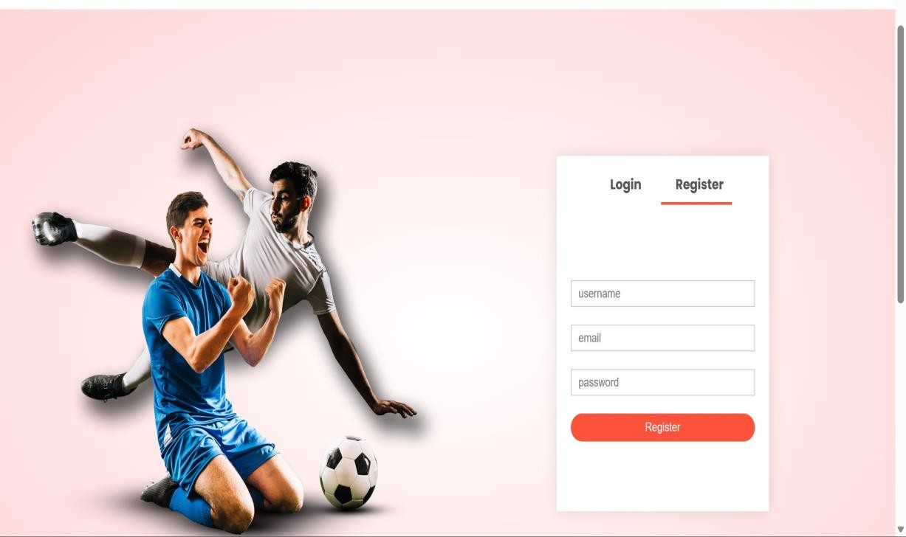

**Conclusion:**

Before this project, I don’t have much experience on web development, so I spent a lot of time learning HTML. In the process, I find web development can be very funny and I certainly enjoy building my own website. For the last several lectures, I’ve learned a lot about software architecture and its importance. For all projected I worked before, I never spent time designing and chose architecture for the system and just blindly start coding without any plans ahead. In this project, however, I documented before coding, which is very helpful in the whole process. Although it is a little time-consuming to document first, but spending time analyzing and thinking about the project that I was to build really makes me understand the project more and makes coding really easy. Software architecture is already helpful for me to implement a

relatively small project, I don’t doubt its importance for large-scale projects that involve lots of people.